Example: Skater rolls up ramp

* Ignoring friction and air resistance
* Enough energy to get to the top of the hill

But E = KE + GPE [**Stays constant**]

Energy transformation: Process where energy stays constant

* Fixed

Energy Transfer: Process where the energy of system changes

* Not constant
* Examples
  + Work
    - Person pushes the box (starting at rest) moves to the right and it acquires a speed because it is in a state of motion and it changes its position in the direction of the push
    - Initial KE = 0 [Box]
    - Initial GPE = 0 [Box is flat on the ground]
    - Nothing is changed when the box is moved
    - W [Work] = f [force] * d [distance]
    - E = KE + GPE
    - E [Total energy] = 0 + 0
      * No total energy is acquired
  + Sound
    - Wave [Sinusoidal function]

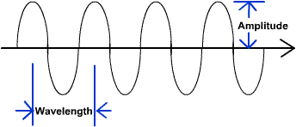

* + - Travelling disturbance in a continuous (i.e → “smooth”) medium (i.e → substance) which carries energy
    - Air density/pressure is going up and down
    - Exists as gases,[speaking], liquids[you can hear underwater], solid [hear someone hit a steel beam with your ear at the end of beam]
    - SOUND CANNOT TRAVEL THROUGH A VACUUM (most notable space)
    - Sound is a million (10^6) slower than light
    - Is also able to do work
  + Heat
  + Electrical Transmission

Spring Potential Energy

* The amount of work done when compressed spring is released